Software Engineering 2017

# Group ID: B04

## *Traffic Challan Management*

|  |
| --- |
| 20171005_230039.jpg |

|  |  |  |
| --- | --- | --- |
| Roll Number | Name | Role (PO+DEV/SM+DEV/DEV) |
| 15ucs121 | Satyam Kumar | DEV |
| 15ucs138 | Shubham Mangal | SM + DEV |
| 15ucs154 | Utsav Singh | PO + DEV |
| 15ucs122 | Satyam Shubham | DEV |
| 15ucs108 | Rishabh Tiwari | DEV |

*+ order the names as per the order in the team selfie (left to right)*

**Section 1**

|  |
| --- |
| **Project overview**  Traffic Challan Management system provides the following functionality:   1. Offers the data about commuters using their vehicle’s license number, 2. Penalize the road rules offenders by issuing the challan against the vehicle’s license number, 3. Helps the traffic officer to manage and regulate the challan generation automatically and hassle free, 4. Provide platform to pay the challan fine amount online |

|  |
| --- |
| **System purpose**  To reduce difficult paperwork of challan generation by traffic officer, to efficiently generate challan and reduce the time consumed in manual work, to provide better traffic regulations, and to provide online platform for offenders to pay fine. |

**Section 2**

**URI for System Demo**

[**Demo Link**](https://t-challan.firebaseapp.com/)

**Login Details:** [**admin@tchallan.com**](mailto:admin@tchallan.com) **admin96**

**URI for UI/UX wireframes (shared Lucidchart document folder)**

[**Lucid Folder Link**](https://www.lucidchart.com/invitations/accept/b21cf4ca-f300-4ebf-be6b-9441bb8b975f)

**URI for Scrum project management report (shared Google Drive folder)**

[**Scrum Burndown Chart**](https://docs.google.com/a/lnmiit.ac.in/spreadsheets/d/19CKbj7voB_XqLPR1imq7zm9rq9j1quwTVfvpu1Lnj0c/edit?usp=sharing)

**Section 3**

**Work System Snapshot**

|  |  |  |  |
| --- | --- | --- | --- |
| Customers | | Product/Services | |
| * Traffic Police Authority | | * Challan Generation * Offender Information * Challan Payment * Challan Insights * Traffic Offences Details * Officer Details | |
| Major Activities and Processes | | | |
| * Admin adds details about commuters against their license number * Admin create officers account with appropriate access rights * Traffic officer upload the image of offenders vehicle containing license number * System generate challan from the processed image * System informs the offender about the challan and payment due date * Offender visits the portal and pay the fine for challan * Wireless Control Officer checks status of payment and reminds the offender about the payment due date in case of no payment. * System update the status of due challan to “waiting court order” * Wireless Control Officer Update the status of due challan to “warrant issued” in case of no response from offender * Wireless Control Officer assign a Police Officer to the Challan * Police Officer checks if any offender’s warrant is issued * Police Officer update the status of offender’s arrest * Wireless Control Officer closes the challan after all processing * Commuters can view for any previous challan issued for their vehicle | | | |
| Participants | Information | | Technologies |
| * Offenders * Commuters * Traffic Officer * Police Officer * Wireless Control Officer * Administrator | * License Number * Offender * Challan * Traffic Offences * Payment * Assigned Officer * Warrant | | * Image Processing System * Database System * Payment Providers * Management System |

**Section 4**

**Use case diagram with nested boundary**[**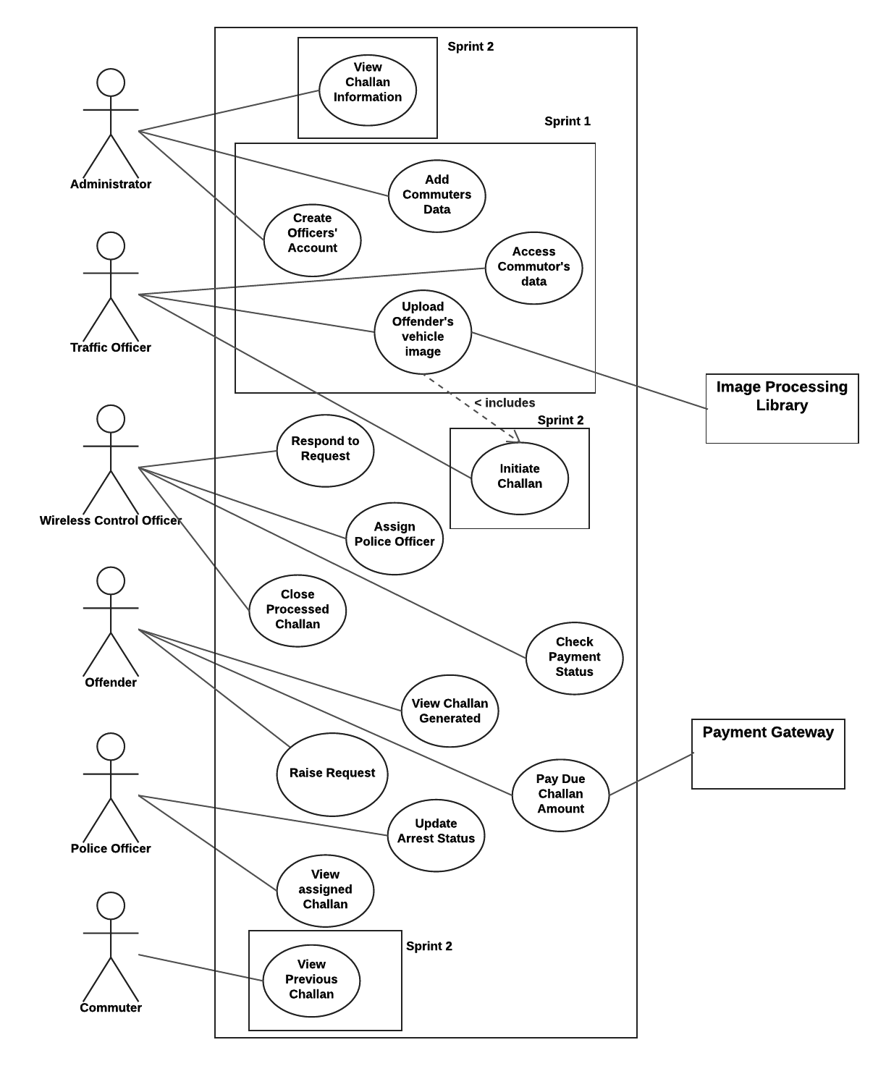**](https://www.lucidchart.com/documents/edit/59287be1-79a7-48e9-a94a-4b51be7a2571/0?callback=close&name=docs&callback_type=back&v=2389&s=612)

**Section 5**

**Product Backlog (format sprint 2 rows in bold)**

|  |  |  |  |  |
| --- | --- | --- | --- | --- |
| Story ID | As a/an | I want to … | so that … | Priority (H/M/L) |
| **1** | **Administrator** | **View road offences** | **Road code of conduct can be ensured** | **L** |
| 2 | Traffic Officer | Upload vehicle image and initiate challan generation | Time consumed in paperwork can be reduced | H |
| 3 | Traffic Officer | View offenders  information | Offender can be informed about challan | M |

|  |  |  |  |  |
| --- | --- | --- | --- | --- |
| Story ID | As a/an | I want to … | so that … | Priority (H/M/L) |
| **4** | **Commuter** | **View challan history** | **I can see if I have violated any road code.** | **L** |
| 5 | Offender | Access challan | I can pay the challan amount. | H |
| **6** | **Wireless Control**  **Officer** | **View challans’ details** | **I can check if challan has been paid or not.** | H |

|  |  |  |  |  |
| --- | --- | --- | --- | --- |
| Story ID | As a/an | I want to … | so that … | Priority (H/M/L) |
| 7 | Wireless Control  Officer | Inform Court about the  unpaid challan | Appropriate actions can be  taken against offender by  Court. | M |
| 8 | Wireless Control  Officer | View the warrant  information issued by  court | I can assign the police officer  to the warrant. | M |

|  |  |  |  |  |
| --- | --- | --- | --- | --- |
| Story ID | As a/an | I want to … | so that … | Priority (H/M/L) |
| 9 | Police Officer | View assigned  warrants | I can take appropriate actions  accordingly. | M |
| 10 | Administrator | Create and assign  officers’ accounts | They can upload and manage  challan. | H |

**Sprint 2 Plan (Backlog)**

|  |  |  |  |  |  |
| --- | --- | --- | --- | --- | --- |
| Story ID | As a/an | I want to … | so that … | estimate | actual |
| **1** | **Administrator** | **View road offences** | **Road code of conduct can be ensured** | 2 day |  |
| **4** | **Commuter** | **View challan history** | **I can see if I have violated any road code.** | 3 day |  |
| **6** | **Wireless Control**  **Officer** | **View challans’ details** | **I can check if challan has been paid or not.** | 2 days |  |

**Section 6**

**Acceptance criteria and test result**

(note: a story ID may have multiple rows; one for each acceptance criteria to be tested)

|  |  |  |
| --- | --- | --- |
| Story ID | Acceptance criteria | Test Result |
| 1 | Only administrator should be able to add offences | Accepted |
| 1 | Offences are accessible by everyone | Accepted |
| 4 | Challan history related to a user should only shown to him | Accepted |
| 4 | Challan history is visible | Accepted |
| 6 | Status of challan is editable | Accepted |
| 6 | Only Police Officer can change status | Accepted |

**Section 7**

**Personas**

**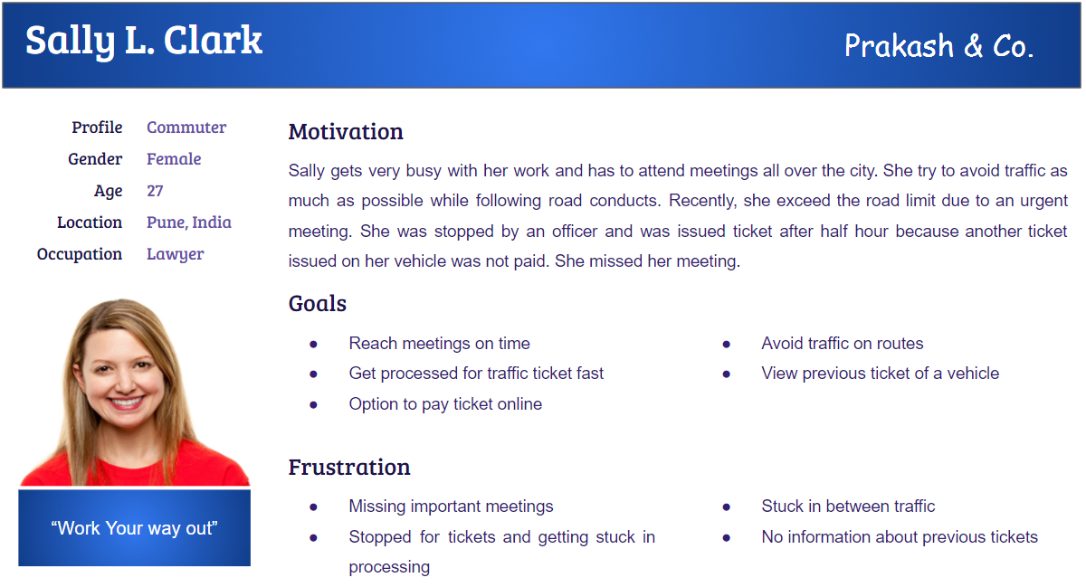**

**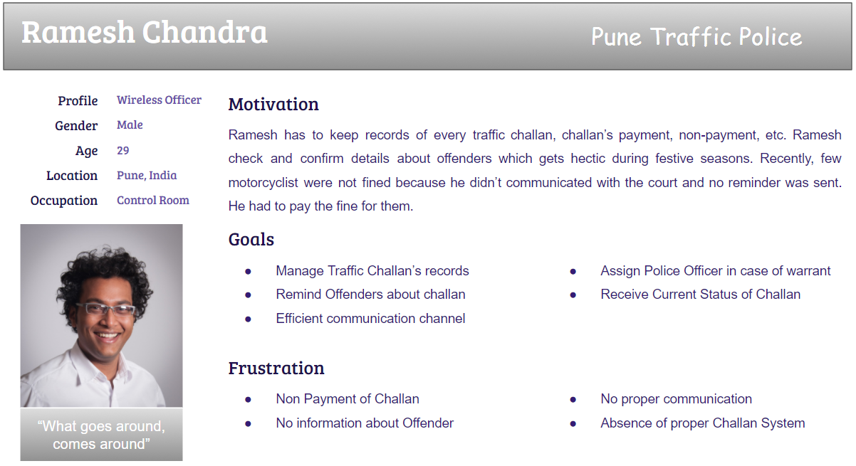**

**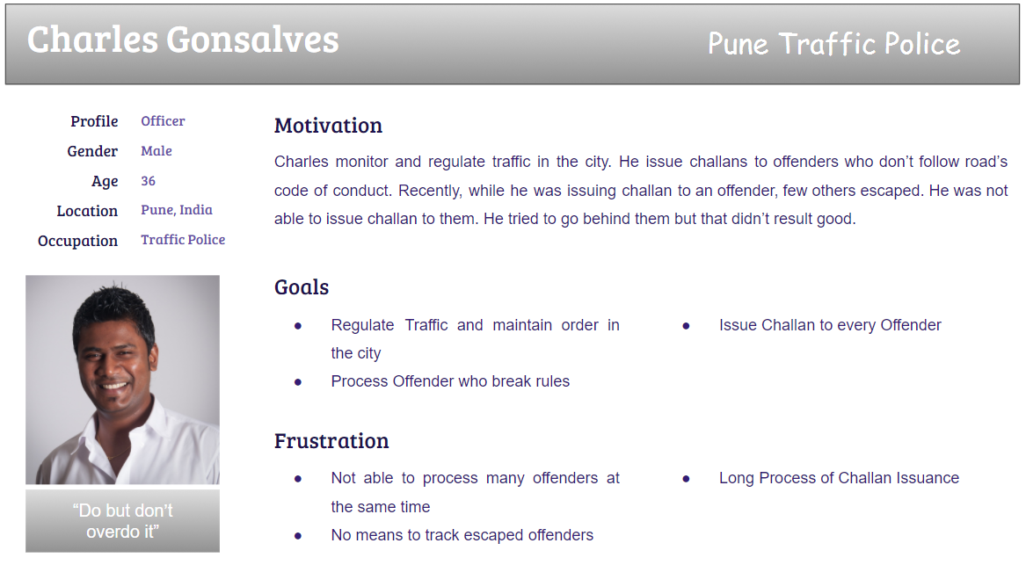**

**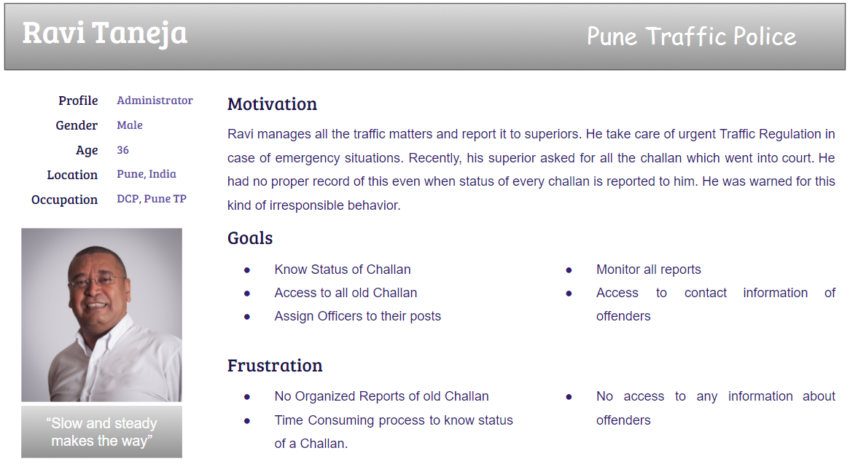**

**Section 8**

**Activity diagram – Top level**

<*linking all the use cases in the use case diagram*>

[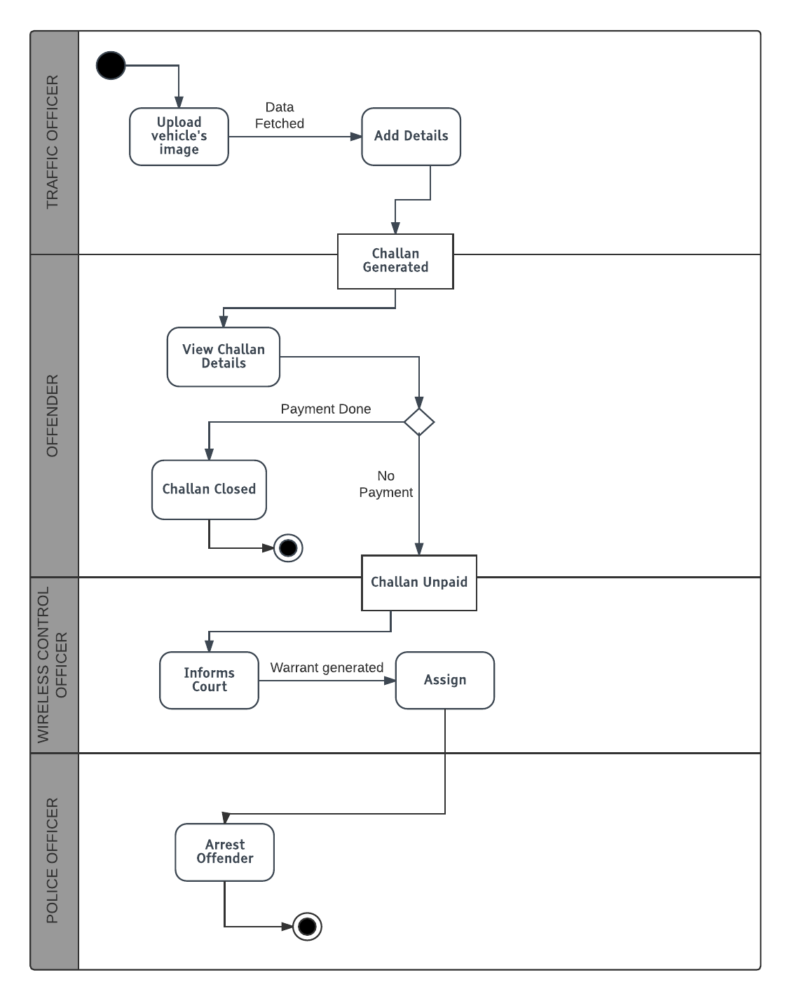](https://www.lucidchart.com/documents/edit/13f750a7-2ebb-43e8-b5f4-b136463ea6e9/0?callback=close&name=docs&callback_type=back&v=829&s=565)

**Activity diagrams**

<*Approximately one for each team member with correct notation; diagrams should include business activities/operations – not UI navigation and concepts*>

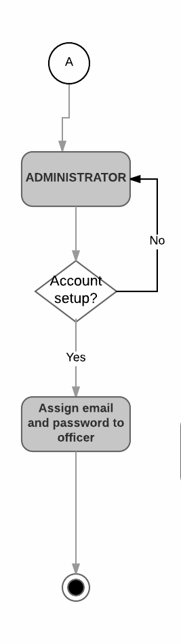

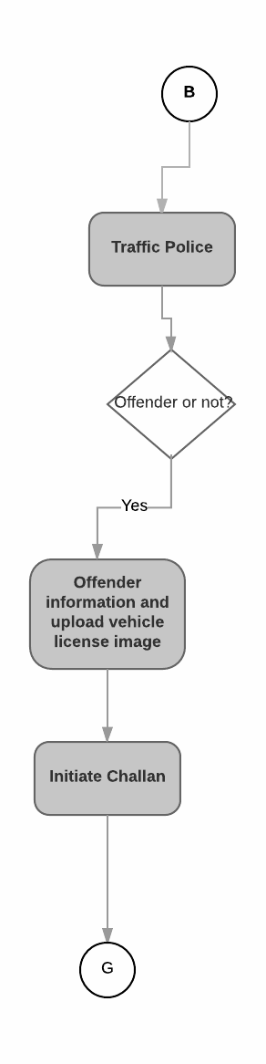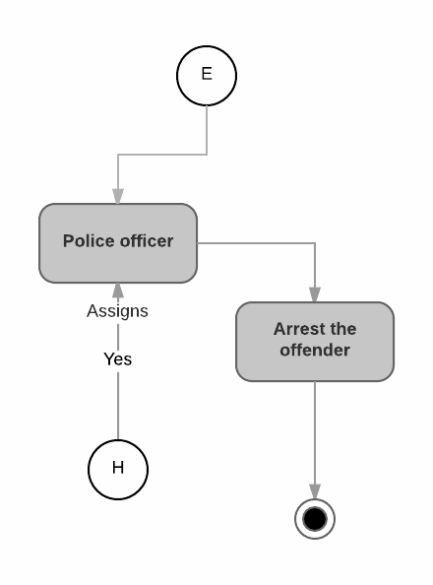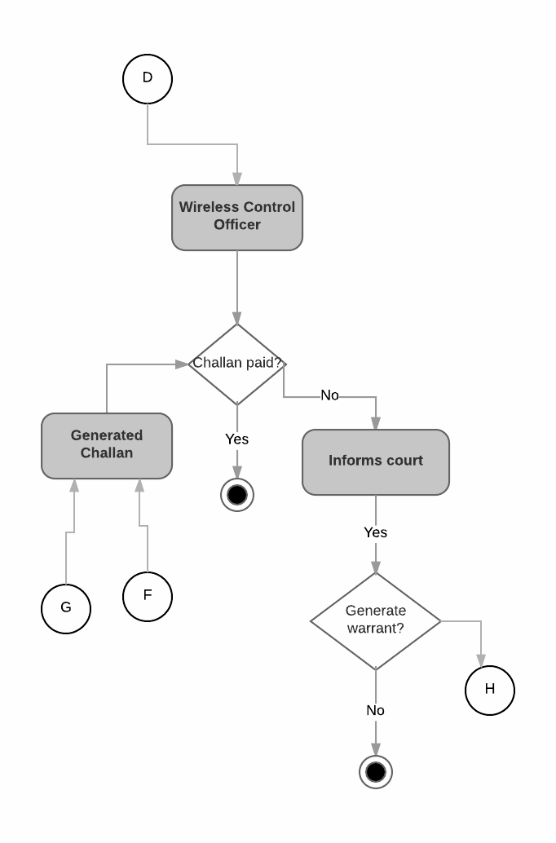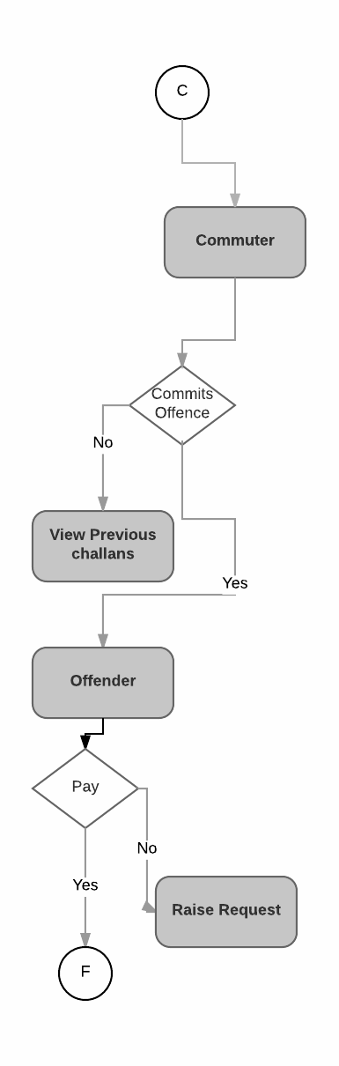

**Section 9**

**Mindmaps for UX/UI for Persona Groups**

**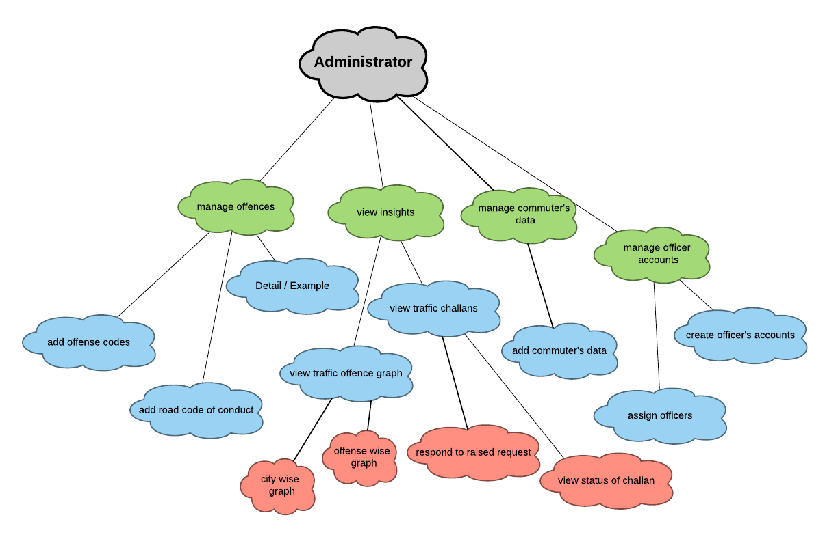**

**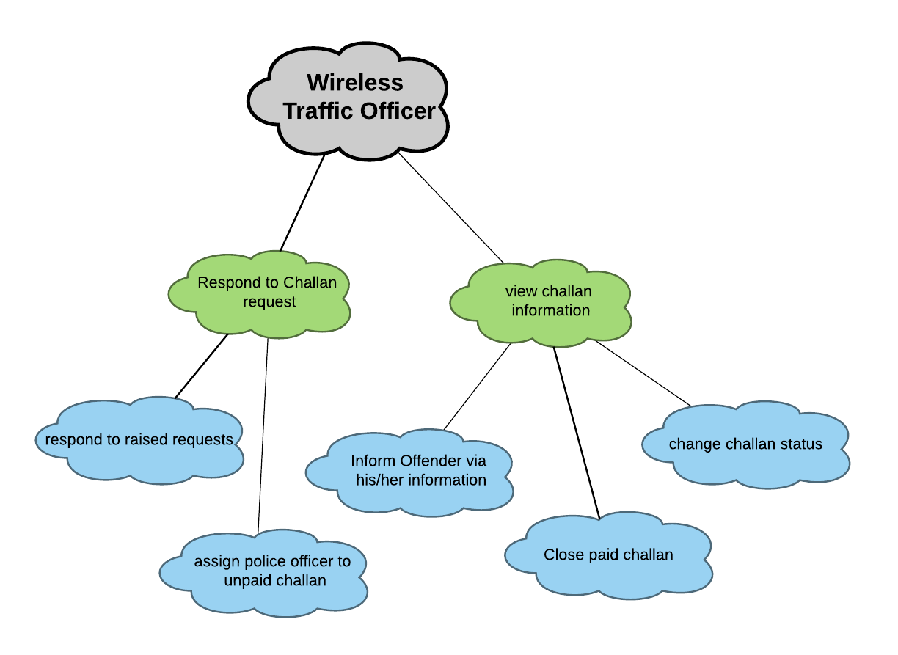**

[**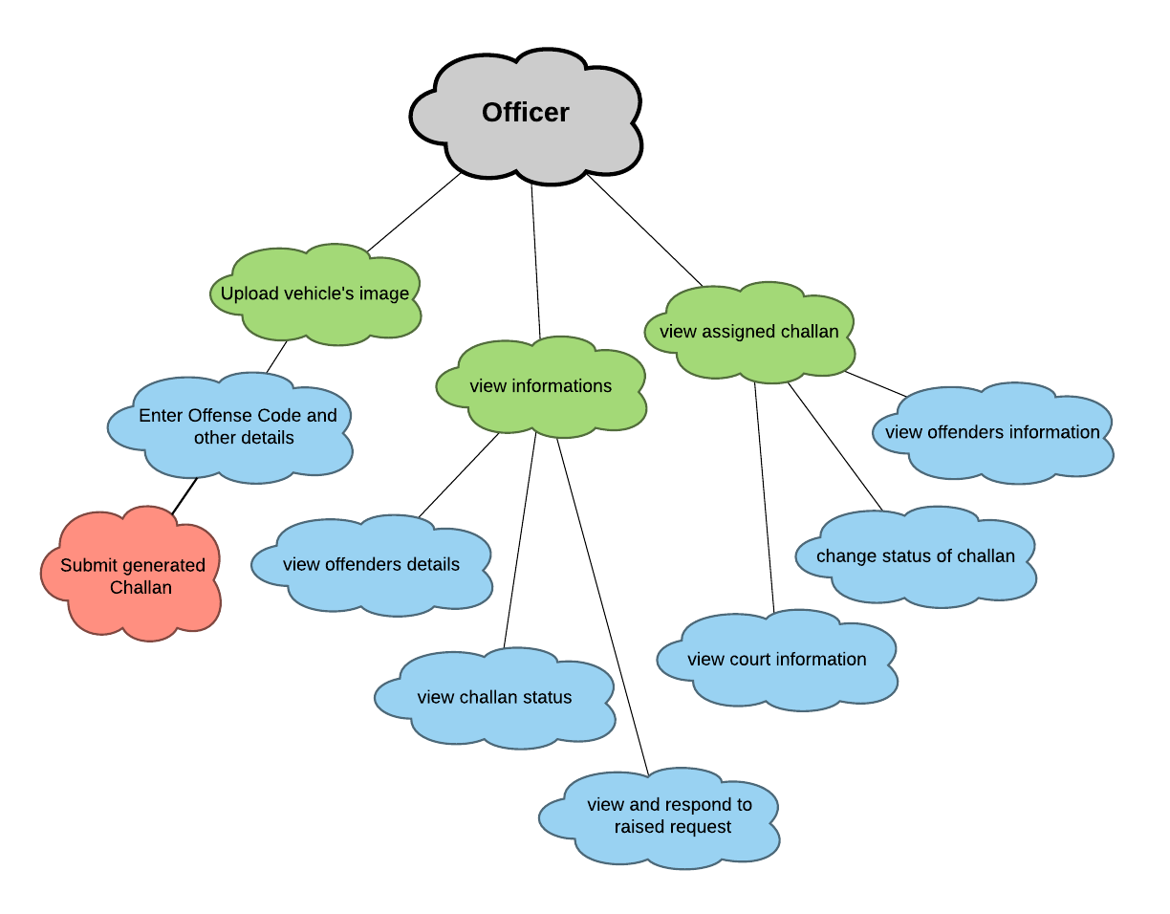**](https://www.lucidchart.com/documents/edit/ce7b4e94-f7a5-4953-b26e-1a3334af5821/0?callback=close&name=docs&callback_type=back&v=1129&s=612)[**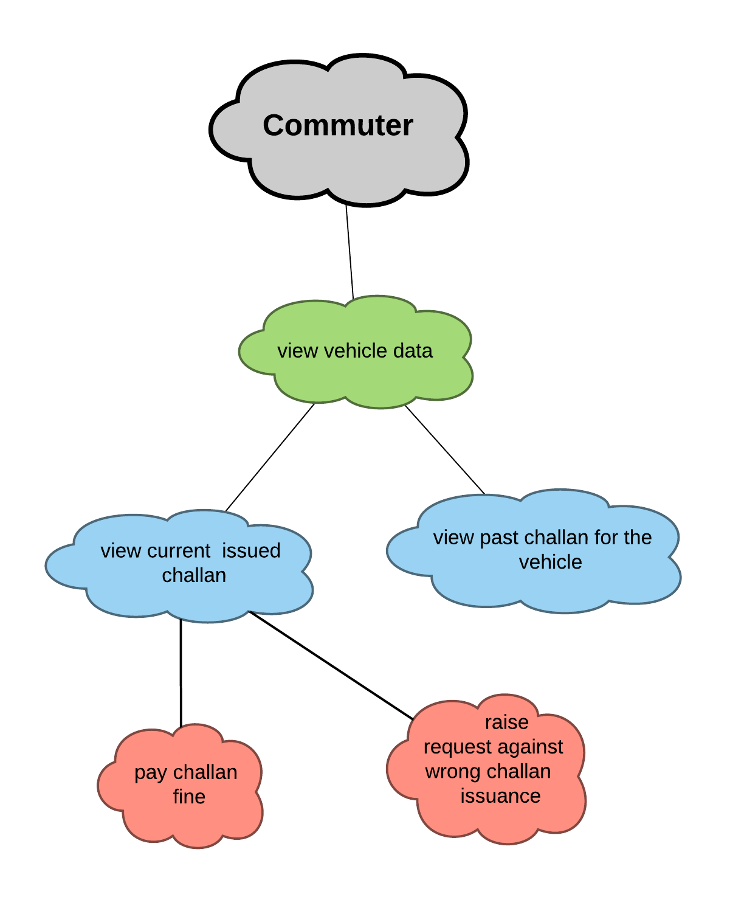**](https://www.lucidchart.com/documents/edit/51aec5b3-a41a-41b3-854e-e1c8e1702908/0?callback=close&name=docs&callback_type=back&v=962&s=612)

**Section 10**

**UI/UX Designs (Wireframes) – For the Sprint 2 functionality**

**Home Page**

**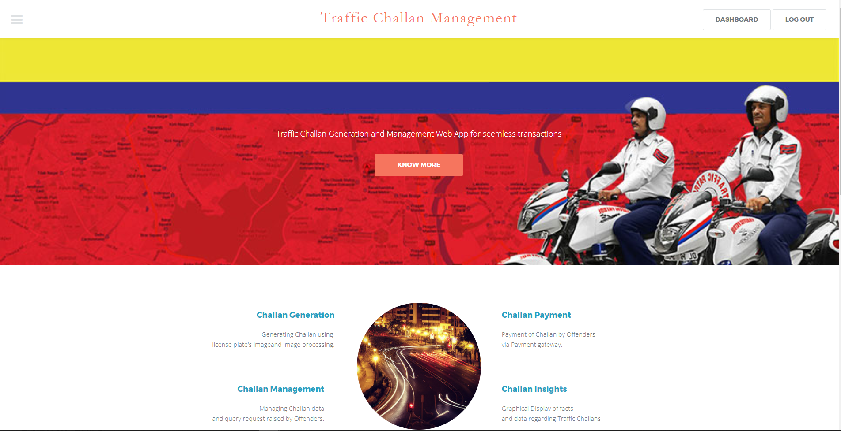**

**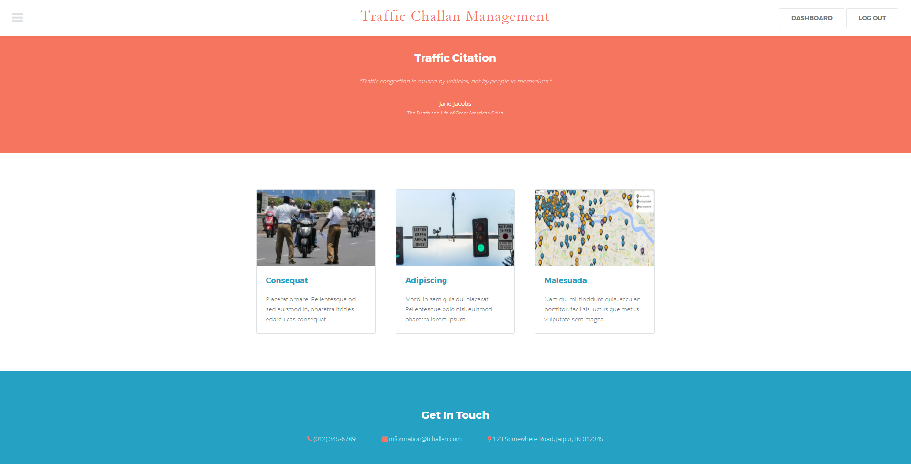**

**Login Page**

**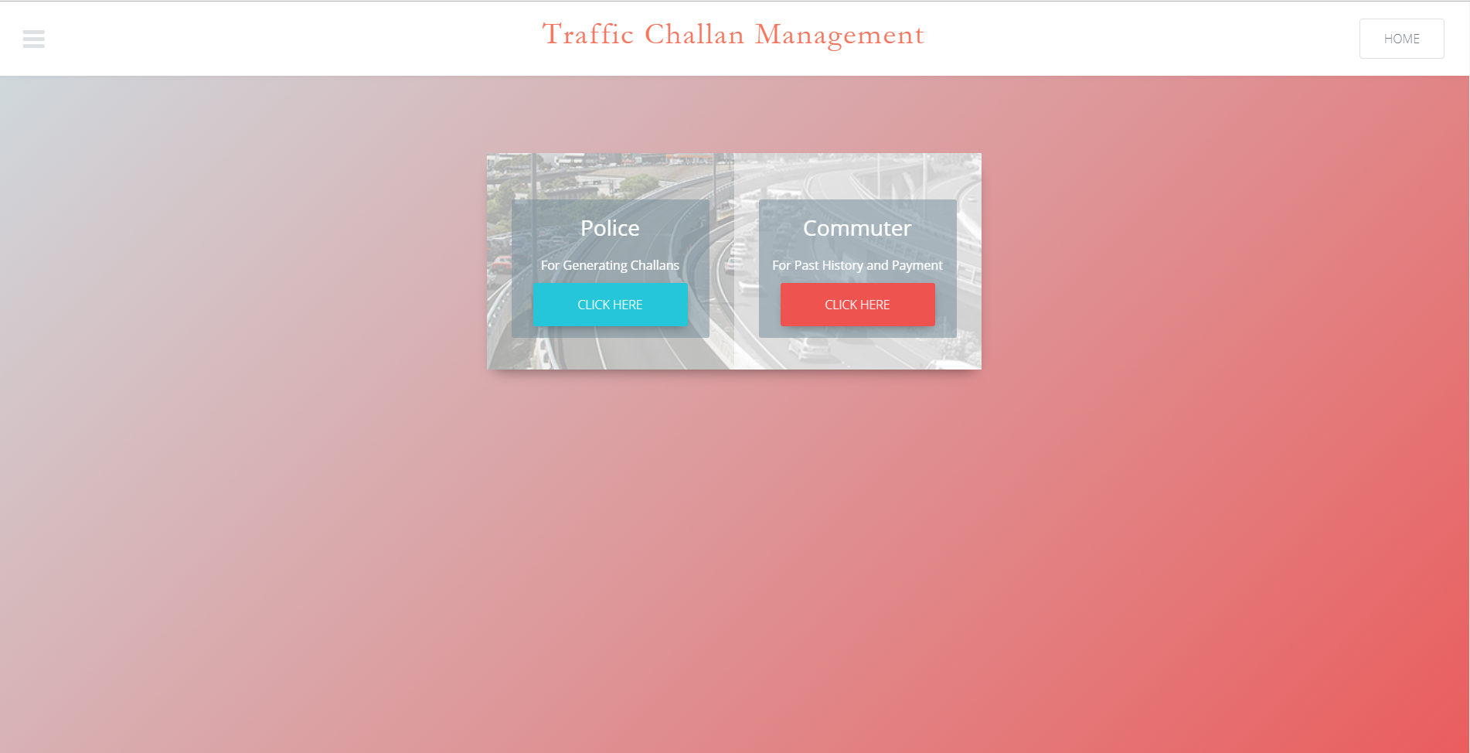**

**Police Login**

**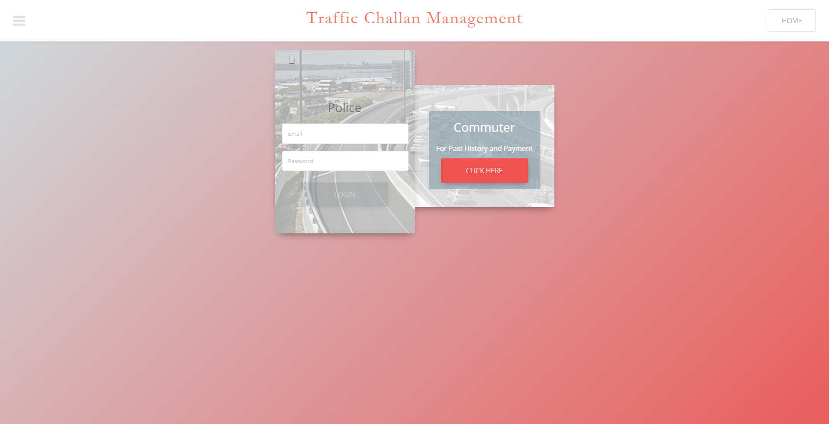**

**Commuter Login**

**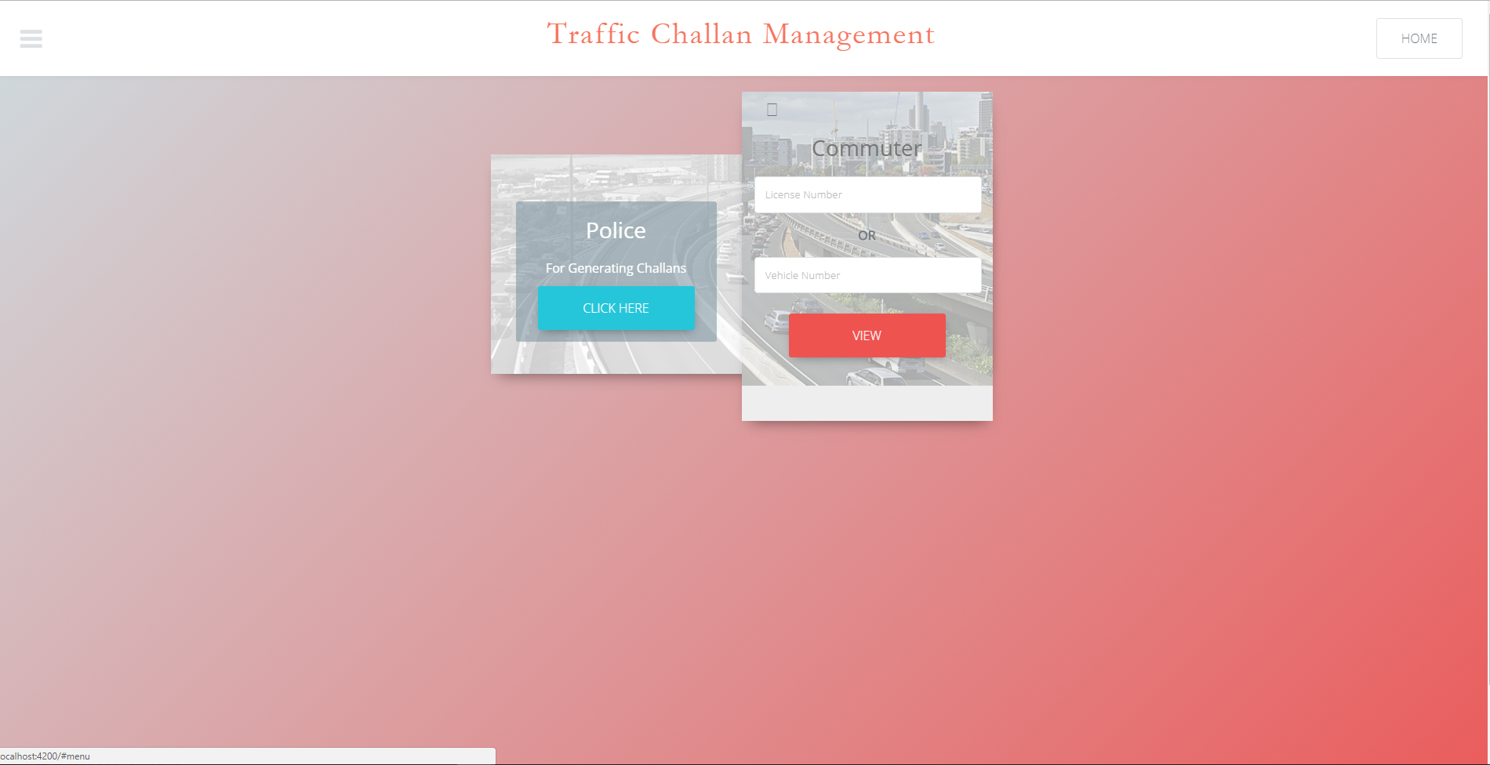**

**Admin Dashboard**

**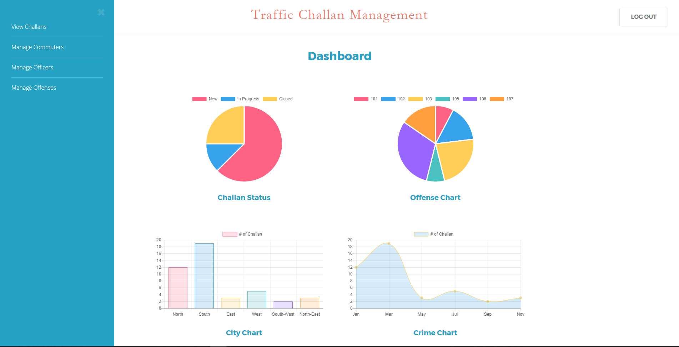**

**Commuter**

**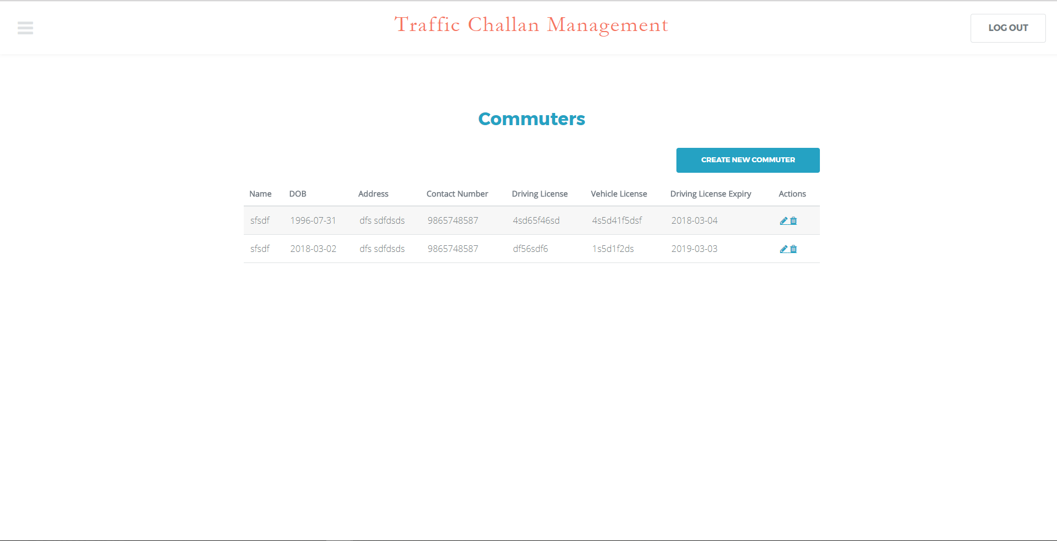**

**Commuter Create**

**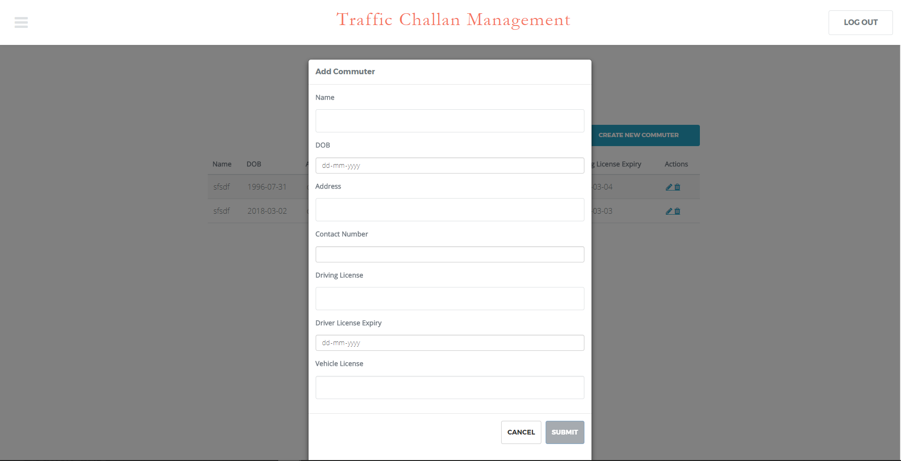**

**Commuter Edit**

**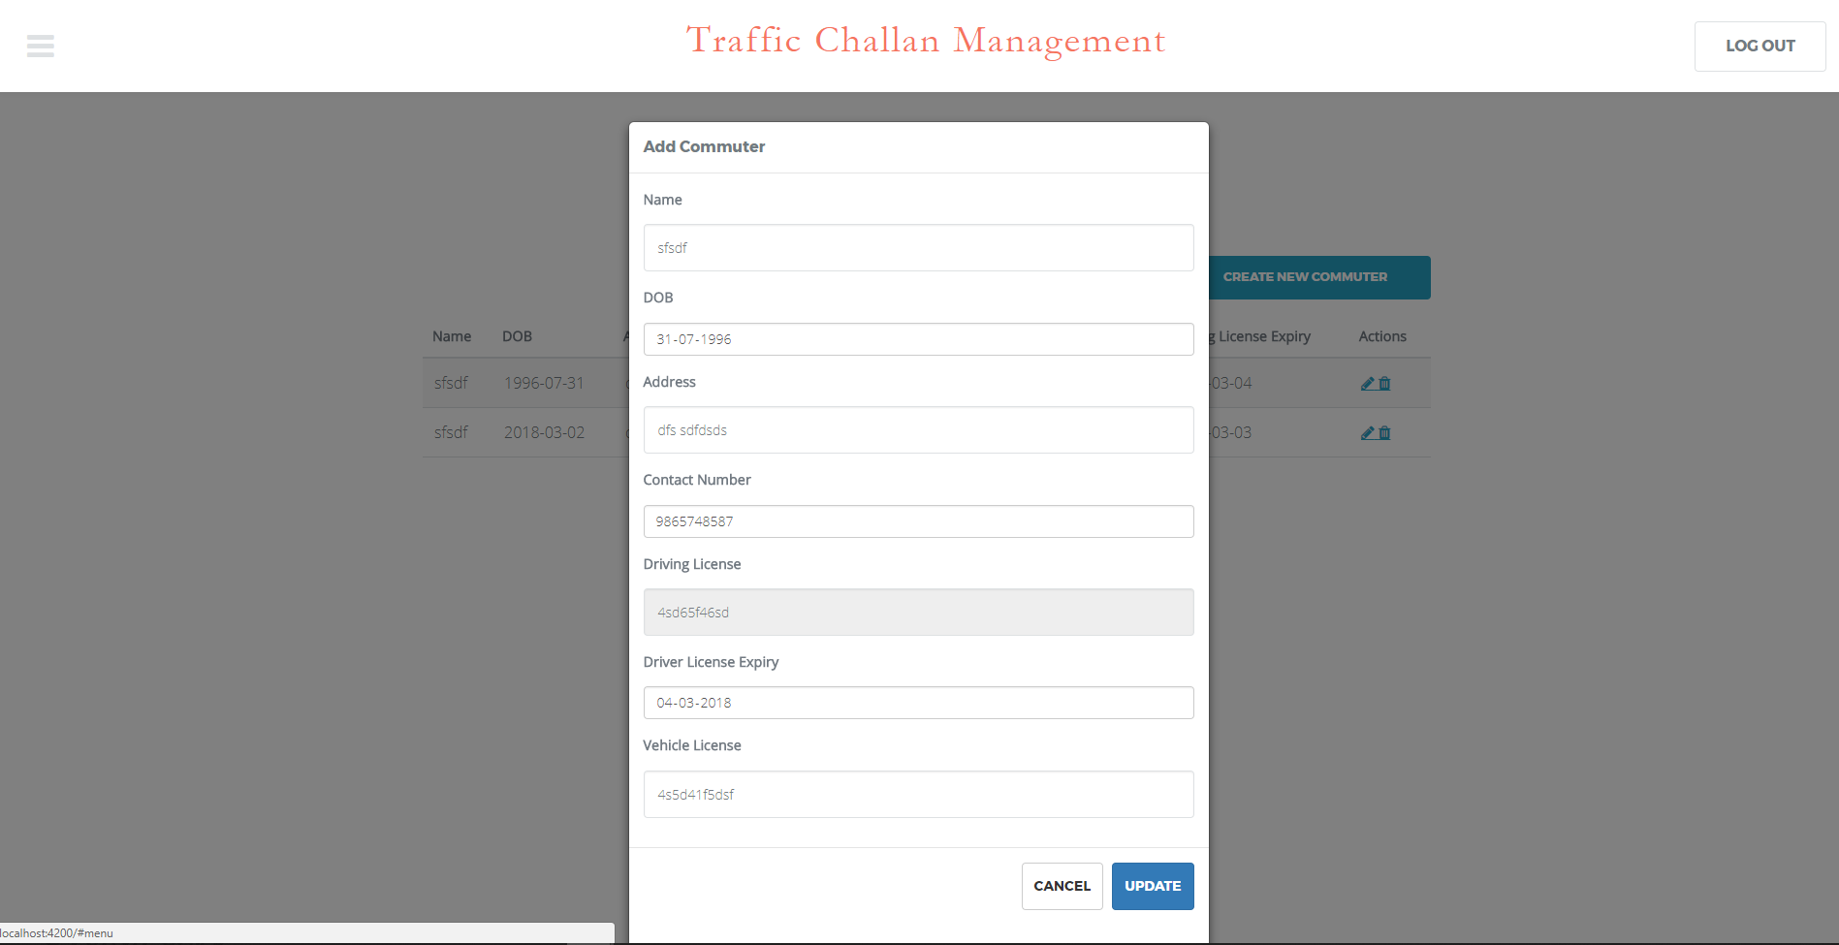**

**Section 11**

**Class diagram**

<attributes and operations should be listed on the following pages as a table>

[**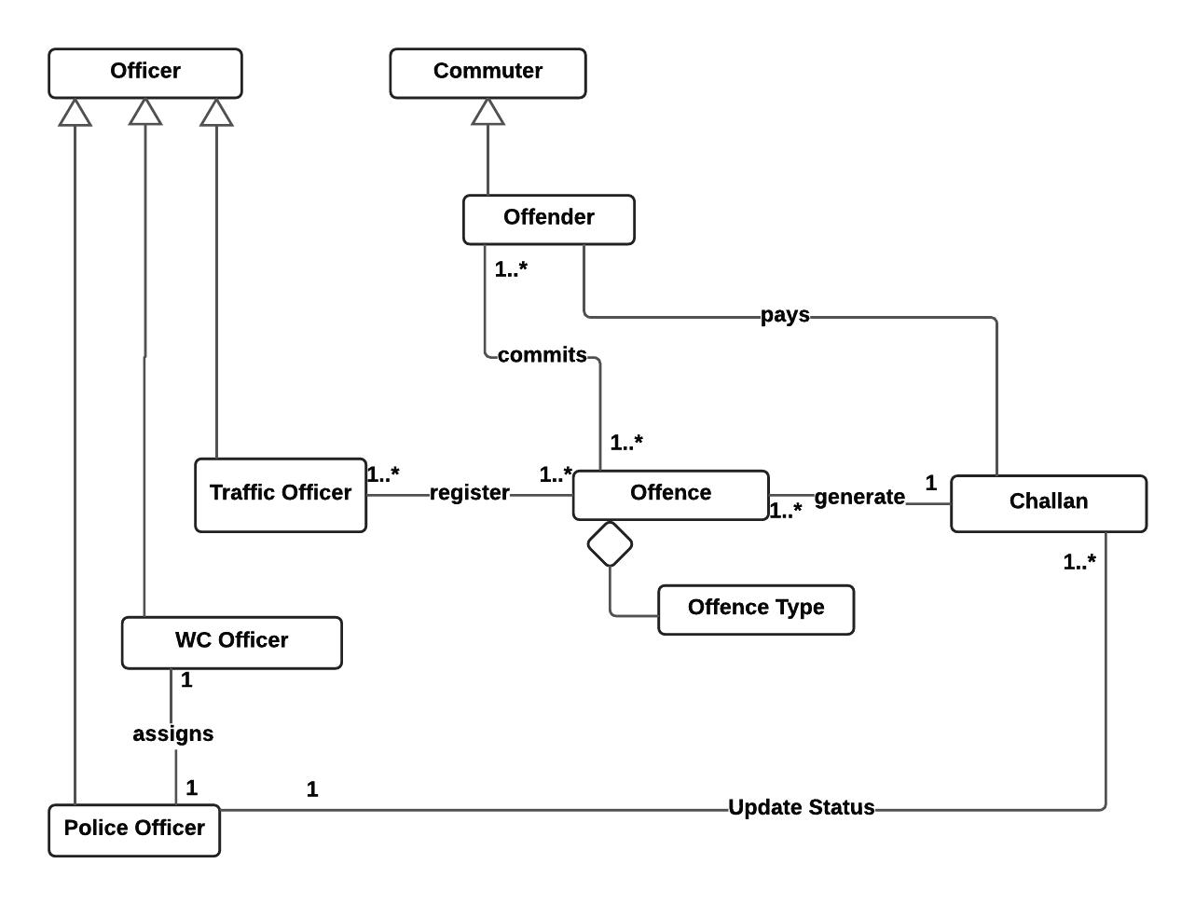**](https://www.lucidchart.com/documents/edit/91d5f803-aef0-4268-8478-fd55957a6d84/0?callback=close&name=docs&callback_type=back&v=3302&s=641)

**Attributes and operations**

(show class attributes and operations with underline)

|  |  |  |
| --- | --- | --- |
| Class name | Attributes | Operations |
| Offence | date  location  offenceType  vehicle\_details | getDetails() |
| Commuter | name  dl\_no  dob  address  contact\_number  dl\_expiry  vehicle\_plate\_number | getCommuter(dl\_no)  getCommuter(vehicle\_plate\_number)  getCommuters()  addCommuter(Commuter)  getAge()  getRemainingDays() |
| Officer | name  precinct  badge\_number  type | getOfficer(badge\_number)  getOfficers()  getOfficers(type)  createOfficer(Officer) |
| Challan | date  location  challan\_number  offence: OFFENCE  offender: OFFENDER  payment\_due\_date  status  officer: OFFICER  court\_date  is\_warrant\_issued  arrest\_status  assignedto | getChallan(challan\_number)  getChallans()  getStatus(challan\_number)  getFine()  getWarrantStatus(challan\_number)  getArrestStatus(challan\_number)  getDueDays() |
| OffenceType | code  description  points  cost | getOffenceCost(code)  getOffences()  createOffence(Offence) |

**Section 12**

**System Architecture**

[**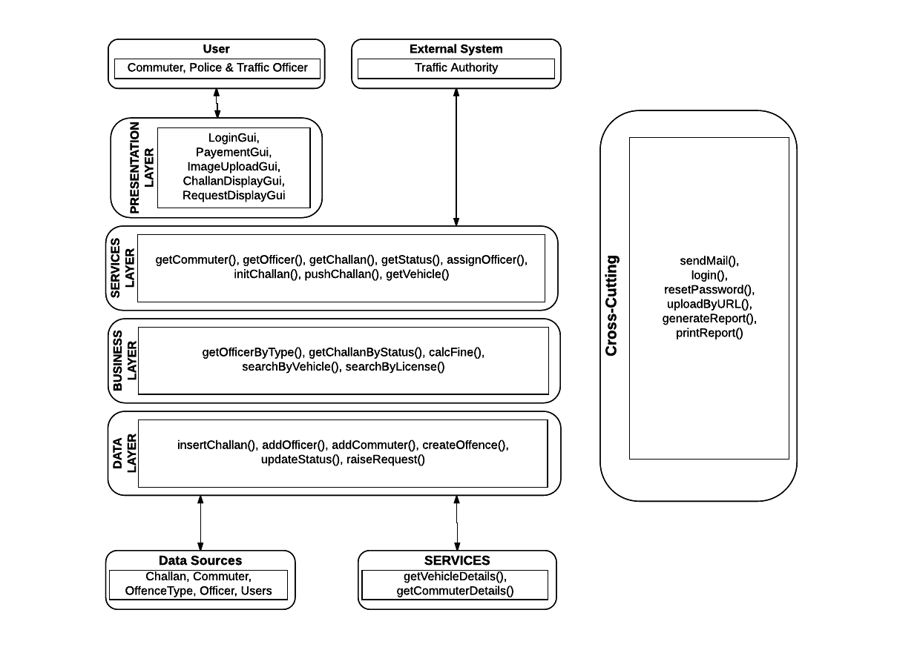**](https://www.lucidchart.com/documents/edit/86f0018b-669b-48d7-9f62-3a98ee2a3dca/0?callback=close&name=docs&callback_type=back&v=2785&s=620)

**Scrum Minutes of the Meeting (Two entries per week for each team member)**

**Sprint 2 – Week 1**

|  |  |  |  |
| --- | --- | --- | --- |
| Team member | Work completed | Work planned | Impediments |
| Rishabh Tiwari | completed | build offence data schema | none |
| Satyam Kumar | completed | make UI frames for home pages | none |
| Satyam Shubham | completed | make UI frames for home pages | none |
| Shubham Mangal | partially completed | port from firebase database to firebase firestore | none |
| Utsav Singh | partially completed | gather dummy data | none |

**Week 1**

|  |  |  |  |
| --- | --- | --- | --- |
| Team member | Work completed | Work planned | Impediments |
| Rishabh Tiwari | completed | build class for offence | none |
| Satyam Kumar | completed | identify methods for class offence | none |
| Satyam Shubham | completed | test the homepage responsiveness | hard to make mobile compatible |
| Shubham Mangal | completed | code home page | none |
| Utsav Singh | completed | implement css for home page | Learning css |

**Week 4**

|  |  |  |  |
| --- | --- | --- | --- |
| Team member | Work completed | Work planned | Impediments |
| Rishabh Tiwari | completed | worked on dashboard UI | none |
| Satyam Kumar | completed | worked on chart data | need to get precise data |
| Satyam Shubham | completed | build UI/UX for navbar and sidebar | no difficulty |
| Shubham Mangal | completed | configured chartjs to display charts | none |
| Utsav Singh | completed | tested the implementation of others | testing and debugging hard |

**Week 4**

|  |  |  |  |
| --- | --- | --- | --- |
| Team member | Work completed | Work planned | Impediments |
| Rishabh Tiwari | completed | save recognized data from image | Json is difficult to maintain |
| Satyam Kumar | completed | identify methods for classes | no difficulty |
| Satyam Shubham | completed | tested overall implementation and removed bugs | no difficulty |
| Shubham Mangal | completed | Complete the burndown chart as well as scrum meetings summary finally | no difficulty |
| Utsav Singh | completed | worked creating tabular form of data | no difficulty |

**Sprint 2 Summary**

**Review Summary (about the product)**

|  |  |
| --- | --- |
| 1 | UI/UX are working efficiently,  User can login into his/her account,  Database queries are working,  Administrator is able to see all data |
| 2 | Creation of commuter data, offence data is fast,  Officer’s account can be created,  Vehicle’s image can be uploaded,  Data about image is being fetched |
| 3 | website is hosted on firebase |

**Retrospective Summary (about the process)**

|  |  |
| --- | --- |
| 1 | Using NoSql via firestore is proving to be very feasible as database’s schema is changing frequently,  scheming the database is tedious task |
| 2 | Authentication is done via firebase API which is taking care of login and logout of users, |
| 3 | Data fetched from the Recognition API contains recognized plate and vehicle details |